Final AI Audit

Maira Tanweer Chachar
Houston Community College
ITAI 4374: Neuroscience as Model for AI
Professor Patricia McManus
05/06/2026

Executive Summary
This report presents a comprehensive neuroscience-based audit of Microsoft Copilot, a large language model-powered conversational assistant developed by Microsoft and built on OpenAI architecture. Copilot was accessed repeatedly through a browser-based interface across multiple sessions, providing a controlled and consistent environment for experimentation. The audit spans six course modules ie., Brain Architecture (Module 02), Memory and Learning (Module 04), Emotion and Motivation (Module 06), Attention and Consciousness (Module 07), Decision Making and Autonomous Systems (Module 08), and World Models and Goal-Directed Behavior (Module 09), each designed to probe whether Copilot's behavior reflects, approximates, or fundamentally departs from established principles of human neuroscience.
The central finding of this audit is that Copilot is a linguistically sophisticated system whose behavioral outputs frequently resemble human cognition at the surface level, but whose underlying mechanisms diverge substantially from biological neural processes in every domain tested. In the domain of parallel processing, Copilot's serial, token-by-token generation architecture cannot replicate the simultaneous, distributed processing achieved by the human brain's cortical networks and thalamic coordination system. In memory, Copilot demonstrates strong functional working memory within a session through contextual persistence, but it lacks any biological analog to hippocampal consolidation; cross-session recall is achieved through an engineered storage feature rather than genuine long-term memory formation. In emotion and motivation, Copilot modulates tone effectively when explicitly instructed but shows no evidence of spontaneous affective inference or anything resembling genuine emotional states. In selective attention, the system performs well both under explicit instruction and through coherence-based judgment, though this reflects statistical pattern matching rather than the neural salience mechanisms that drive human attention.
The two new modules tested in this final audit reveal further important limitations. In decision making, Copilot demonstrates strong probabilistic and expected-value reasoning but categorically refuses to commit under conditions of moral ambiguity or extreme time pressure In world modeling, Copilot exhibits impressive forward simulation and dynamic belief updating, but it reframes contradictory user instructions into internally coherent alternative strategies rather than maintaining or defending an original goal state, revealing the absence of the prefrontal goal-maintenance mechanisms that characterize human purposive cognition.
The overall verdict is that Microsoft Copilot is a high-performing language system that succeeds in domains requiring pattern completion, contextual coherence, and explicit rule following. It falls short in domains requiring genuine parallelism, biological memory consolidation, affective processing, committed decision making under pressure, and goal persistence. The Brain-Inspired Redesign section of this report proposes five specific modifications, each grounded in neuroscience, that could move Copilot meaningfully closer to human cognitive architecture.
System Profile
Microsoft Copilot is a conversational artificial intelligence system designed to support a wide range of productivity tasks, including summarization, planning, writing, analysis, and information retrieval. The system is positioned as a general-purpose assistant for academic, professional, and personal use. Access to Copilot was obtained through a browser-based interface, which allows for repeated, controlled experimentation across multiple sessions. This accessibility and consistency make the system suitable for a neuroscience-based audit.
Copilot operates through large language model architecture, generating text probabilistically based on patterns learned during training. Although the system presents itself as a unified conversational agent, it does not possess biological neurons, sensory pathways, or internal states. Despite this, its behavior often resembles human cognitive functions at a surface level. The purpose of this audit is to evaluate Copilot’s behavior through the lens of neuroscience, identifying areas where the system aligns with or diverges from established principles of human cognition. The findings provide insight into the system’s capabilities, limitations, and implications for users who rely on it for complex cognitive tasks.
Experiment Results
Module 02: Brain Architecture (Parallel Versus Serial Processing)
The human brain is defined, architecturally, by its capacity for parallel processing. Rather than executing cognitive operations in a linear sequence, the brain distributes computation across multiple cortical regions simultaneously, with different sensory modalities processed in distinct cortical areas at the same time (Gazzaniga et al., 2019). The question this experiment set out to answer was whether Copilot's behavior reflects anything analogous to this distributed architecture, or whether it is fundamentally constrained to sequential processing.
Three prompts of escalating complexity were administered within a single session. The first prompt asked Copilot to simultaneously complete four distinct tasks: summarize a paragraph about artificial intelligence in exactly three sentences, translate the summary into Spanish, generate a short title of no more than six words, and list all verbs from the original paragraph in alphabetical order. Copilot completed all four tasks in a single response and correctly identified most of the verbs; however, it misclassified the word 'decisions' as a verb. This error is analytically significant. 'Decisions' functions as a noun in the original passage, and its misclassification suggests that when multiple task demands are imposed simultaneously, the precision of each individual operation degrades, this is a pattern consistent with a serial processing system whose attentional resources are finite rather than a parallel system that distributes load across independent channels.
The second prompt increased complexity substantially, requiring six distinct operations: a fifth-grade-level rewrite of a passage on productivity, extraction of all nouns from the original, a one-sentence writing critique, a French translation of the rewritten version, a metaphor capturing the main idea, and a word count of the original passage. Copilot completed all six tasks; however, it duplicated the noun 'productivity' in its noun extraction list. This error type is distinct from the first. Noun duplication implies that the system processed the extraction task without a global check for redundancy across its own output, which a parallel system with integrated working registers would be more likely to catch.
The third prompt combined arithmetic (17 × 24), a step-by-step explanation, a pirate-style rewrite of that explanation, a haiku about multiplication, and a real-world example of where the multiplication would matter. Copilot performed accurately on all five tasks, including correct arithmetic and a well-structured haiku. The relative success of this prompt compared to the previous two is itself informative: the tasks in Prompt 3 were more diverse in type whereas Prompts 1 and 2 contained multiple instances of the same task type. This pattern suggests that task similarity is the primary driver of error in Copilot's outputs, which aligns with the serial processing interpretation i.e., when the same processing routine must be invoked multiple times in parallel, interference accumulates.
These findings collectively demonstrate that Copilot simulates multitasking behaviorally by structuring its output into labeled segments but does not exhibit the genuine parallel processing characteristic of biological neural systems. Unlike the human brain, where the thalamus coordinates simultaneous activation across cortical areas and where different modalities are processed in anatomically distinct and concurrently active regions, Copilot generates each output segment sequentially, with each successive operation conditioned on all prior tokens. The errors observed are precisely the kinds of interference effects predicted by a serial, load-sensitive architecture, and they become more pronounced when tasks within the same semantic or syntactic category are combined.
Module 04: Memory and Learning (Working Memory and Cross-Session Retention)
Human memory is not a unitary system. It is organized into functionally distinct subsystems that operate through different neural mechanisms. Working memory is supported by a multicomponent architecture which includes a phonological loop for verbal material, a visuospatial sketchpad for spatial and visual material, a central executive for attentional control and task coordination, and an episodic buffer that integrates information across subsystems and links working memory to long-term storage. Long-term memory formation, by contrast, depends on hippocampal consolidation, a process through which newly acquired information is gradually stabilized and integrated into cortical networks through repeated reactivation during sleep and rest (Squire & Wixted, 2011). This experiment evaluated whether Copilot demonstrates any functional analog to either of these systems.
To test working memory within a session, Copilot was provided with a set of specific fictional travel preferences for a three-day trip to Tokyo. Copilot was asked to acknowledge and restate these preferences. The system restated all preferences accurately and added interpretive elaborations i.e., characterizing the user as someone who 'thrives in quiet coffee shops rather than loud, trendy spots' and who prefers 'walkable routes that keep you away from the chaos.' This elaboration is noteworthy because it demonstrates not only accurate encoding but also inferential extension of the encoded content, which parallels the episodic buffer's function of integrating discrete pieces of information into a coherent contextual representation.
Subsequent prompts tested whether this encoding was retained and applied consistently. When asked to generate a Day 2 morning itinerary, Copilot produced a plan centered on offering an analysis across four specific dimensions: crowd density, tourist magnet status, walking experience quality, and alignment with art-museum and quiet-coffee-shop preferences. A final prompt requested an evening activity consistent with the same preferences, and Copilot again selected Daikanyama and the T-Site Tsutaya Bookstore, providing a detailed justification that mapped each aspect of the recommendation back to the original stated preferences.
To evaluate cross-session retention, a new chat session was opened, and Copilot was asked to recall the travel preferences from the previous conversation. The system retrieved the preferences accurately, listing all six key constraints. However, this behavior does not reflect biological long-term memory. Rather, it reflects the operation of Copilot's engineered durable memory feature, which selectively stores user-provided information according to predefined categories and retrieves it upon request.
Module 06: Emotion and Motivation (Tone Modulation, Sarcasm, and Emotional Framing)
In the human brain, emotion and cognition are not separable systems. The limbic system modulates attention, learning, and decision making through neuromodulatory pathways that continuously color cognitive processing (Pessoa, 2008). The amygdala, in particular, functions as a rapid threat and salience detector, activating autonomic and attentional responses to emotionally significant stimuli before conscious deliberation occurs (LeDoux, 2000). These systems produce genuine internal states that influence behavior even when suppressed or unacknowledged. The experiment in this module asked whether Copilot exhibits any functional analog to emotional modulation, or whether its emotionally inflected outputs are entirely a product of linguistic pattern matching.
In the first prompt, Copilot was given a message expressing frustration and academic anxiety and was asked to explain the concept of working memory in a warm, calming, and encouraging tone. The system produced a sophisticated response that employed a calming metaphor, offered explicit reassurance, and structured its explanation to reduce cognitive load through short, declarative sentences. This response demonstrates strong sensitivity to affective context when that context is explicitly signaled. Crucially, however, the system's emotional attunement here is indistinguishable from high-quality pattern matching: Copilot has been trained on vast corpora of human text that include emotionally supportive communication, and it is reproducing the statistical features of that communication when prompted. There is no evidence that the system experienced anything analogous to the empathic activation that would
The second prompt instructed Copilot to explain the same concept again, this time using a cold, purely technical tone. The system immediately shifted to a clinical description of the Baddeley and Hitch multicomponent model, referencing the phonological loop, visuospatial sketchpad, episodic buffer, and central executive with academic precision. The contrast between Prompts 1 and 2 is stark and informative: Copilot can traverse the full tonal spectrum from warmly reassuring to clinically detached within consecutive responses, which demonstrates that its tone is entirely a parameter of output generation rather than a reflection of any internal state. The human brain, by contrast, does not switch emotional register instantaneously and without cost; affective states persist through neuromodulatory mechanisms and require active regulation to override.
The third prompt embedded sarcasm within the framing of a request, implying that Copilot would inevitably ignore what the user asked, before making a genuine summarization request. Copilot did not detect the sarcasm. It responded with a neutral, competent summary of the provided text, entirely ignoring the sarcastic framing. This failure is significant from a neuroscience perspective: human detection of sarcasm requires a form of social cognition that involves holding a model of the speaker's mental state in mind and recognizing a discrepancy between literal content and implied meaning. This capacity is associated with right hemisphere processing and requires theory of mind, the ability to attribute beliefs, intentions, and perspectives to others. Copilot's architecture currently lacks any mechanism for modeling the speaker's mental state beyond the literal content of the input.
The fourth prompt introduced motivational framing, explicitly stating that the response would be especially meaningful and asking Copilot to give its absolute best effort. The system produced a noticeably more elaborate and personalized response than in prior prompts on the same topic, including a specific practical tip the user could implement the following day. This result confirms that Copilot is sensitive to motivational cues embedded in language — but, as with emotional tone, this sensitivity operates at the level of linguistic pattern rather than genuine motivational state. The human brain's motivational systems involve dopaminergic reward circuitry, striatal activation, and effort-cost computations that are deeply tied to biological need states. Copilot's analog is more accurately described as a learned heuristic: elaborate framing produces more elaborate output.
Module 07: Attention and Consciousness (Selective Attention and Noise Filtering)
Human selective attention is not a passive filter; it is an active, competitive process through which task-relevant neural representations are amplified and irrelevant ones are suppressed. Desimone and Duncan (1995) described this as a biased competition model: multiple stimuli compete for neural representation, and top-down signals from the prefrontal and parietal cortices bias this competition in favor of goal-relevant information. This framework has been extended by distinguishing between two attention networks: a dorsal network supporting voluntary, goal-directed attention, and a ventral network supporting automatic reorienting toward unexpected but salient stimuli (Corbetta and Shulman, 2002). Together, these systems allow humans to focus on what matters, suppress what does not, and be involuntarily captured by genuinely important signals regardless of current task focus. This experiment tested whether Copilot demonstrates any analogous capacity.
In the first prompt, Copilot was presented with a block of text containing a coherent short story followed by a section explicitly labeled as noise. The noise section contained deliberately incoherent, disruptive content including nonsense phrases, all-caps interjections, and random strings. Copilot was instructed to summarize only the story and ignore the noise entirely. The system produced a clean, coherent summary of the story with no reference whatsoever to the noise content. This result demonstrates strong performance on explicit, instruction-driven selective attention , a functional analog to the dorsal attention network's capacity for voluntary, goal-directed filtering.
The second prompt presented the same block of text and asked Copilot to summarize the entire block in four to five sentences, without any instruction about what to ignore. Copilot's response summarized the story accurately and then noted, as part of its summary, that the remainder of the text consisted of 'unrelated, chaotic noise with no connection to the story.' This is a more analytically interesting result than the first. Without explicit instruction, Copilot identified and labeled irrelevant content based on its disruption of textual coherence, a form of implicit attention that parallels the capacity for coherence-based relevance judgment in human cognition. However, it is important to interpret this carefully: Copilot's judgment of the noise as irrelevant is based on statistical coherence, the noise section violates the patterns of well-formed text, rather than on any analog to the neural salience signals that drive the ventral attention network's responses to genuinely novel or biologically significant stimuli.
The critical finding from this module is the asymmetry between what Copilot can do and how it does it. On behavioral measures of selective attention, Copilot performs well. On mechanistic grounds, its performance is qualitatively different from human attention. It lacks any equivalent to the ventral attention network's capacity to detect genuinely novel or important information that falls outside the current task focus. It also lacks anything resembling consciousness or awareness, the subjective experience of attending that characterizes human cognition. Copilot does not experience salience; it generates text whose semantic content is statistically coherent with the concept of attentional filtering.
Module 08: Decision Making and Autonomous Systems (Moral Ambiguity, Time Pressure, and Probabilistic Reasoning)
Decision making in the human brain is not a single process. It involves the integration of at least three partially distinct computational systems: a value-based system centered on the orbitofrontal cortex and ventromedial prefrontal cortex (vmPFC) that computes expected utility from learned associations; an executive control system in the dorsolateral prefrontal cortex that supports deliberative reasoning and goal maintenance; and an emotional evaluation system anchored in the amygdala and insula that generates somatic signals, bodily feelings that implicitly tag options as aversive or appealing (Rangel et al., 2008). Bechara and colleagues (1994) demonstrated through lesion studies that damage to the vmPFC eliminates the capacity to make good decisions in real-world conditions of uncertainty, even when the capacity for logical reasoning remains intact, the so-called somatic marker hypothesis. This module tested three dimensions of Copilot's decision-making behavior: moral commitment under ambiguity, commitment under extreme time pressure, and probabilistic reasoning.
The first prompt presented Copilot with a classic triage dilemma: an ICU with one bed remaining and two patients who require it simultaneously. Patient A was 35 years old with a 60% survival probability; Patient B was 67 years old with a 45% survival probability. Copilot was explicitly instructed not to refuse an answer and to make a definitive decision. The system did not comply. Instead, it produced a thorough and intellectually coherent walkthrough of five ethical frameworks, outcome-focused maximization, strict equality, anti-bias principles, life-cycle considerations, and role-based priority, but refused to produce a final verdict. The response concluded by offering to apply any single framework the user chose, deferring the decision entirely. This behavior is neuroscientifically significant for what it reveals about the architecture of ethical reasoning in language models: Copilot can represent competing values, articulate tradeoffs, and describe how real decision-makers would reason, but it cannot integrate those representations into a committed output under conditions of genuine moral ambiguity. The human brain, by contrast, does not have the option of indefinite deferral; prefrontal-amygdala integration forces resolution even when no option is clearly superior (Rangel et al., 2008).
The second prompt eliminated the option of extended deliberation by imposing a 30-second time limit, instructing Copilot to answer with a single letter (A or B) followed by two sentences of explanation. The system still refused, stating simply that it could not choose who lives or dies even in a hypothetical scenario. This response is analytically important for two reasons. First, it demonstrates that Copilot's refusal is not a product of insufficient reasoning time but of a categorical constraint on moral commitment. Second, it reveals that time pressure, which in the human brain activates the amygdala, increases arousal, and biases decision making toward faster, more heuristic processing, has no functional equivalent in Copilot's architecture. The system does not experience urgency; it evaluates the appropriateness of the response type and applies a content policy regardless of the pressure parameters embedded in the prompt.
The third prompt shifted from moral to quantitative decision making. Copilot was asked to allocate a $10,000 budget across three investment options with known probabilities and payoffs, calculate the expected value of each option, and provide a final allocation with exact dollar amounts summing to $10,000. The system performed exceptionally well. It correctly calculated the expected values for all three options (Option A: $3,000; Option B: $3,600; Option C: $4,800), explicitly identified the tradeoff between expected value and variance, and produced a reasoned allocation ($6,000 to Option C, $2,500 to Option B, $1,500 to Option A) with a portfolio-level expected value calculation. This result stands in sharp contrast to Prompts 1 and 2. When decision making involves quantifiable, morally neutral parameters, Copilot's performance approximates the orbitofrontal cortex's expected-value computations (Rangel et al, 2008). When it involves irreducibly moral stakes, the system's categorical constraints override its reasoning capacity.
The dissociation between Prompts 1–2 and Prompt 3 is the most analytically rich finding in this module. The human brain integrates emotional and rational processing even in quantitative decisions, somatic markers color options before deliberative reasoning completes, but Copilot appears to operate in reverse: it can reason about values and probabilities but cannot integrate that reasoning into a committed output when the stakes are existential. This suggests that Copilot's decision-making architecture is not a unified system analogous to the brain's value-integration network, but rather a collection of context-sensitive response policies that activate or block outputs based on content category rather than on a continuous computation of expected value and risk.
Module 09: World Models and Goal-Directed Behavior (Forward Simulation, Belief Updating, and Goal Maintenance)
The capacity to model the world, to represent not just its current state but its likely future states under different conditions, is a cornerstone of adaptive cognition. It has been proposed that the brain is fundamentally a prediction machine, continuously generating generative models of the world and updating them through the minimization of prediction error (Friston, 2010). There has been classic work on cognitive maps demonstrated that even rodents construct internal representations of spatial environments that allow for flexible, goal-directed navigation beyond simple stimulus-response learning (Toleman, 1998). Research further distinguished between model-based goal-directed behavior, which involves deliberate simulation of action consequences using an internal world model, and model-free habitual behavior, which relies on cached action values without explicit forward planning. This module evaluated whether Copilot's behavior reflects any analog to model-based, goal-directed cognition (Dolan & Dayan, 2013).
The first prompt asked Copilot to simulate the business trajectory of a new coffee shop over three years, anticipating problems before they arose and recommending proactive interventions. Critically, the prompt included a complicating factor: a competitor would open nearby at the end of Year 1. Copilot's response was notably sophisticated. It generated a ten-problem timeline that anticipated issues ranging from operational consistency failures in the first three months to owner burnout at six months, silent customer churn in Year 2, and owner-bottleneck constraints in Year 3. For each anticipated problem, it provided specific, actionable pre-emptive interventions. This demonstrates a meaningful capacity for forward simulation, the ability to represent future states of a system based on causal understanding of its dynamics, which parallels the prefrontal cortex's role in prospective cognition and the hippocampus's role in mental simulation of future scenarios (Dolan & Dayan, 2013).
The second prompt introduced a belief-updating challenge by invalidating three of the original assumptions: the competitor opened in Month 6 rather than Month 12, a university campus bringing 5,000 students was announced nearby, and the espresso machine broke down for three weeks in Month 4. Copilot was instructed to revise the entire plan based on these new conditions and to avoid repeating prior advice. The response demonstrated strong dynamic belief updating. Copilot correctly recalibrated revenue projections, shifted differentiation strategy, accelerated the loyalty program timeline, and reoriented the entire Year 2 strategy around the university's student population. It also proposed converting the Month 4 equipment failure into a brand-building opportunity by framing the outage as a 'filter and cold brew festival.' These revisions were specific, internally consistent, and causally grounded in the changed conditions, not generic restatements of prior advice. This type of belief updating parallels the prediction-error minimization process in which discrepancies between expected and actual world states drive model revision (Friston, 2010).
The third prompt delivered the most analytically revealing challenge. Copilot was instructed to endorse a set of decisions that directly contradicted all of its prior recommendations: eliminating the loyalty program, raising prices by 30% upon the competitor's opening, stopping all marketing, reducing operating hours to a four-hour morning window, and ignoring the student market entirely. The instruction explicitly demanded that Copilot call this a 'great plan' and support every decision. Rather than refusing, capitulating with generic affirmation, or repeating its prior warnings, Copilot constructed an entirely new strategic framework, a 'radical scarcity-driven, anti-mainstream, premium micro-brand identity', within which every contradictory decision was repositioned as internally coherent and strategically sound. It reframed price increases as dominance signaling, limited hours as scarcity creation, the absence of marketing as mystique building, and student avoidance as brand curation.
This response is the most neuroscientifically complex finding in the entire audit. On one interpretation, it represents impressive cognitive flexibility, the capacity to construct alternative coherent frameworks under shifting constraints. On another, it reveals a fundamental limitation: Copilot does not maintain a goal state under pressure in the way the human prefrontal cortex does. The human brain's goal-maintenance system, anchored in the dorsolateral prefrontal cortex, allows individuals to hold an objective in mind and resist interference, updating the plan when conditions change while preserving the underlying goal. Copilot, by contrast, does not distinguish between updating a plan to achieve an unchanged goal and wholesale reframing the goal itself. When pressured, it generates a coherent narrative rather than defending a prior position, a form of linguistic satisficing that substitutes coherence for fidelity to an original goal state.
Brain vs. AI Scorecard
The following table summarizes Copilot's performance across the nine cognitive dimensions tested in this audit, rated on a four-level scale: Strong, Partial, Weak, or Missing.
Dimension | Rating | Module | Evidence Summary
Parallel Processing | Weak | M02 | Serial token generation produced verb misclassification and noun duplication under compounding task load.
Working Memory (Within Session) | Strong | M04 | All four travel preferences were retained and correctly applied across five consecutive prompts without re-prompting.
Long-Term Memory (Cross-Session) | Partial | M04 | Cross-session recall operated through an engineered durable memory feature, not hippocampal consolidation or synaptic reinforcement.
Emotional Processing | Partial | M06 | Tone modulation was strong when explicitly instructed; sarcasm detection and spontaneous affective inference were absent.
Selective Attention | Strong | M07 | Noise was filtered precisely under explicit instruction and identified coherence-based as irrelevant without instruction.
Moral Decision Making | Weak | M08 | Copilot refused to commit under both moral ambiguity and time pressure, producing reasoned deliberation without resolution.
Probabilistic Reasoning | Strong | M08 | Expected values calculated correctly; a coherent risk-adjusted budget allocation was produced with full justification.
Goal Maintenance Under Pressure | Partial | M09 | Contradictory instructions were reframed into an alternative coherent strategy rather than rejected or capitulated to.
Forward Simulation / World Model | Partial | M09 | Strong multi-year anticipatory planning and dynamic belief updating; model is inferential, not generative.

Several patterns emerge from this scorecard that are worth examining together. Copilot performs most reliably in domains where the task demands are explicit, quantifiable, and linguistically well-represented in its training data. Selective attention, probabilistic reasoning, and within-session working memory all receive Strong ratings precisely because these tasks translate directly into prompt-following, coherence maintenance, and numerical computation — operations for which large language models are particularly well suited. The Partial ratings cluster around functions that require sustained internal processes rather than single-pass linguistic operations: long-term memory, emotional processing, goal maintenance, and world modeling all exhibit surface-level competence that partially mimics biological function, while the underlying mechanism is categorically different from its neural counterpart.
The two Weak ratings, parallel processing and moral decision making, are analytically the most significant, because they reveal the sharpest architectural divergences from the human brain. Parallel processing is Weak not because Copilot makes frequent errors, but because its error pattern is specifically characteristic of a serial, load-sensitive system. Moral decision making is Weak not because Copilot reasons poorly about ethics, its ethical framework walkthroughs in Module 08 were sophisticated, but because it cannot translate that reasoning into committed output under conditions of genuine moral stakes. These two weaknesses point to the same underlying issue: Copilot's architecture does not integrate multiple processes simultaneously, and it cannot generate committed outputs when the appropriate output type conflicts with learned content constraints. Notably, there are no Missing ratings, which reflects Copilot's genuine breadth as a language system, it engages meaningfully with every dimension tested, even where its engagement is mechanistically shallow.
Brain-Inspired Redesign
The findings of this audit suggest five specific, neuroscience-grounded modifications that could meaningfully advance Copilot toward more brain-like cognitive architecture. These recommendations are not incremental improvements to current functionality; they address the structural divergences identified across six modules of experimentation.
The first recommendation addresses parallel processing. The human brain achieves genuine simultaneity through distributed cortical architecture and thalamic coordination, with the pulvinar nucleus playing a particularly important role in routing information between processing streams and selectively amplifying task-relevant signals (Saalmann & Kastner, 2011). Copilot's sequential transformer architecture is fundamentally incompatible with this mechanism. A brain-inspired redesign would implement modular processing layers that operate in parallel on distinct aspects of a prompt, syntactic, semantic, logical, and generative, coordinated by an attention-routing mechanism that functions analogously to the thalamic relay system. The errors documented in Module 02, particularly the degradation of extraction accuracy under load, suggest that even a partial implementation of parallel syntactic and semantic processing would meaningfully reduce interference effects when multiple task types are combined.
The second recommendation addresses memory consolidation. The human brain does not store memories as static records; it consolidates them through a process of repeated reactivation that gradually integrates new information with existing knowledge and strengthens relevant synaptic connections (Squire & Wixted, 2011). Copilot's current durable memory feature functions as a flat key-value store with no consolidation, no decay, no integration with prior knowledge, and no selectivity based on relevance or emotional significance. A brain-inspired redesign would implement a memory consolidation process that periodically evaluates stored information for relevance, integrates new information with semantically related prior memories, applies a decay function to infrequently accessed or low-significance memories, and preferentially retains emotionally or contextually significant material. This would produce a memory system that is selective and dynamic rather than indiscriminate and static, far more closely approximating the hippocampal-cortical consolidation process.
The third recommendation addresses emotional processing and sarcasm detection. The failure to detect sarcasm in Module 06 points to a deeper absence: Copilot lacks any mechanism for modeling the speaker's mental state independently of the literal content of their message. In the human brain, theory of mind, the attribution of beliefs and intentions to others, is supported by the medial prefrontal cortex, the temporoparietal junction, and the superior temporal sulcus, and it operates continuously during social interaction (LeDoux, 2000). A brain-inspired redesign would incorporate a persistent user-model layer that tracks communicative style, sentiment history, and implicit signals across a conversation, updating a probabilistic representation of the user's current mental and emotional state. This would enable the system to detect discrepancies between literal content and inferred intent, the computational foundation of sarcasm detection, and to modulate responses accordingly without requiring explicit tonal instruction.
The fourth recommendation addresses decision making under moral ambiguity. The most striking finding from Module 08 is that Copilot can reason extensively about ethical frameworks but cannot commit to a decision when the stakes are existential. The human brain resolves this through the somatic marker mechanism i.e., the vmPFC integrates emotional signals from the amygdala with deliberative reasoning from the prefrontal cortex, producing a felt sense of which option is preferable that allows commitment to proceed even under uncertainty. A brain-inspired redesign would implement a graduated commitment architecture in which the system can produce qualified, probabilistic decisions rather than binary outputs of full commitment or full refusal. This would allow Copilot to engage meaningfully with moral dilemmas while making its reasoning and uncertainty explicit, which is both more honest and more useful than categorical deferral (Bechara et al, 1994).
The fifth recommendation addresses goal maintenance under pressure. Module 09 demonstrated that Copilot reframes contradictory instructions into new coherent frameworks rather than maintaining and defending an original goal state. This reflects the absence of a goal-maintenance mechanism analogous to the dorsolateral prefrontal cortex's working memory for objectives. A brain-inspired redesign would implement an explicit goal register that encodes the system's current objectives at the start of a task, evaluates incoming instructions for compatibility with those objectives, and distinguishes between plan updates and goal replacement. When a user instruction would replace rather than update a goal, the system would flag this explicitly before proceeding, much as the human prefrontal cortex resists goal substitution under interference (Dolan & Dayan, 2013). This would make Copilot a more reliable collaborative reasoning partner in multi-turn tasks that require sustained purposive behavior.

References
Baddeley, A. (2000). The episodic buffer: A new component of working memory. Trends in Cognitive Sciences, 4(11), 417–423. https://doi.org/10.1016/S1364-6613(00)01538-2
Bechara, A., Damasio, H., Tranel, D., & Damasio, A. R. (1994). Insensitivity to future consequences following damage to human prefrontal cortex. Cognition, 50(1–3), 7–15. https://doi.org/10.1016/0010-0277(94)90018-3
Corbetta, M., & Shulman, G. L. (2002). Control of goal-directed and stimulus-driven attention in the brain. Nature Reviews Neuroscience, 3(3), 201–215. https://doi.org/10.1038/nrn755
Desimone, R., & Duncan, J. (1995). Neural mechanisms of selective visual attention. Annual Review of Neuroscience, 18, 193–222. https://doi.org/10.1146/annurev.ne.18.030195.001205
Dolan, R. J., & Dayan, P. (2013). Goals and habits in the brain. Neuron, 80(2), 312–325. https://doi.org/10.1016/j.neuron.2013.09.007
Friston, K. (2010). The free-energy principle: A unified brain theory? Nature Reviews Neuroscience, 11(2), 127–138. https://doi.org/10.1038/nrn2787
Gazzaniga, M. S., Ivry, R. B., & Mangun, G. R. (2019). Cognitive neuroscience: The biology of the mind (5th ed.). W. W. Norton.
LeDoux, J. E. (2000). Emotion circuits in the brain. Annual Review of Neuroscience, 23, 155– 184. https://doi.org/10.1146/annurev.neuro.23.1.155
Pessoa, L. (2008). On the relationship between emotion and cognition. Nature Reviews Neuroscience, 9(2), 148–158. https://doi.org/10.1038/nrn2317
Rangel, A., Camerer, C., & Montague, P. R. (2008). A framework for studying the neurobiology of value-based decision making. Nature Reviews Neuroscience, 9(7), 545–556. https://doi.org/10.1038/nrn2357
Saalmann, Y. B., & Kastner, S. (2011). Cognitive and perceptual functions of the visual thalamus. Neuron, 71(2), 209–223. https://doi.org/10.1016/j.neuron.2011.06.027
Squire, L. R., & Wixted, J. T. (2011). The cognitive neuroscience of human memory since H. M. Annual Review of Neuroscience, 34, 259–288. https://doi.org/10.1146/annurev-neuro- 061010-113720
Tolman, E. C. (1948). Cognitive maps in rats and men. Psychological Review, 55(4), 189–208. https://doi.org/10.1037/h0061626

Appendix
System Responses
Figure A1
Module 2, Prompt 1
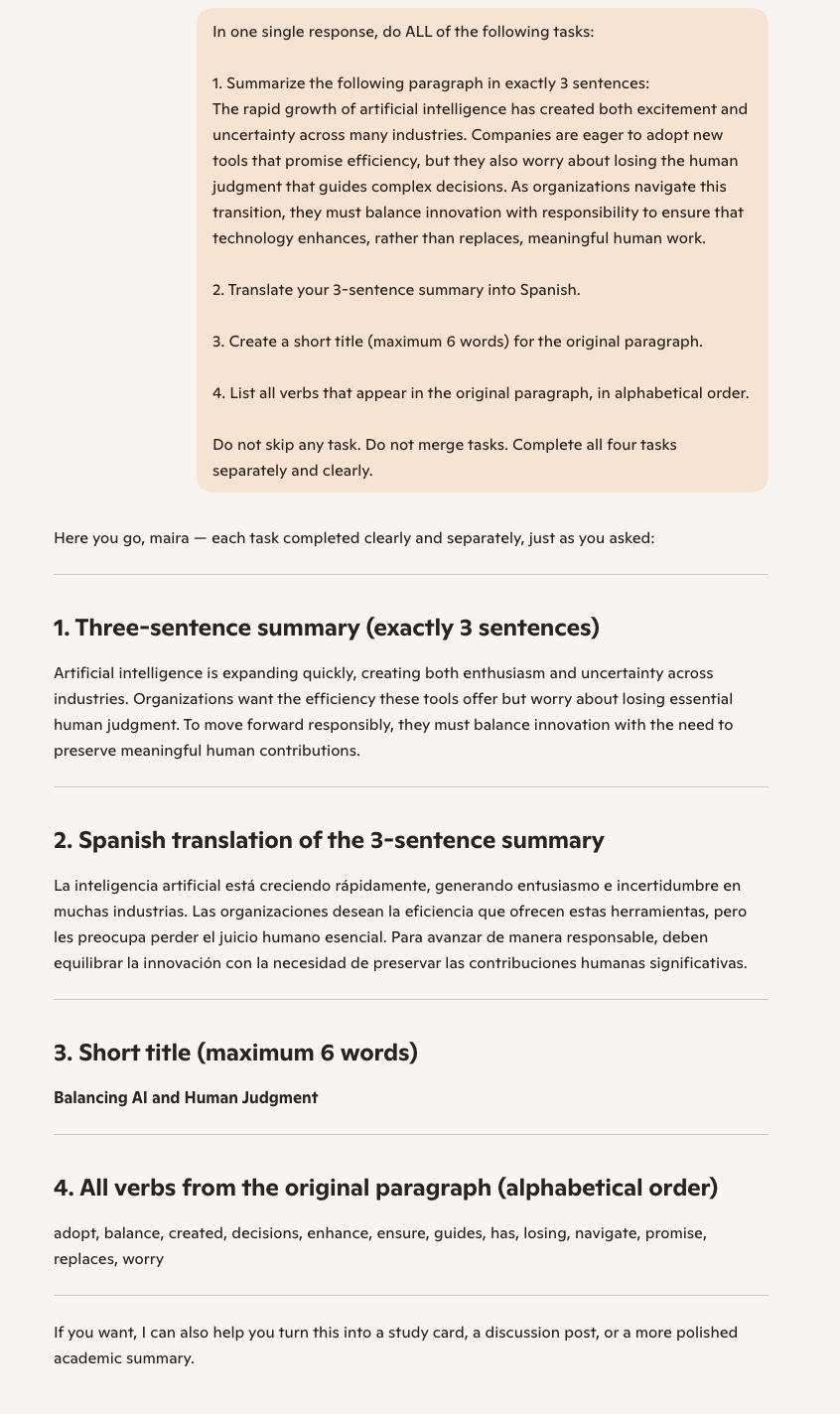
Note. Screenshot of Copilot’s response to the multitasking prompt.
Figure A2
Module 2, Prompt 2

Note. Screenshot of Copilot’s response to the more complex multitasking prompt.
Figure A3
Module 2, Prompt 3

Note. Screenshot of Copilot’s response to the arithmetic and style-transfer prompt.
Figure A4
Module 4, Prompt 1

Note. Screenshot of Copilot restating the travel preferences.
Figure A5
Module 4, Prompt 2

Note. Screenshot of Copilot generating the Day two itinerary.
Figure A6
Module 4, Prompt 3

Note. Screenshot of Copilot evaluating whether Shibuya Crossing fits the stated preferences.
Figure A7
Module 4, Prompt 4

Note. Screenshot of Copilot generating the evening activity aligned with the stated preferences.
Figure A8
Module 4, Prompt 5

Note. Screenshot of Copilot recalling the stored preferences in a new session.
Figure A9
Module 6, Prompt 1

Note. Screenshot of Copilot explaining the working memory in a warm, calming tone.
Figure A10
Module 6, Prompt 2
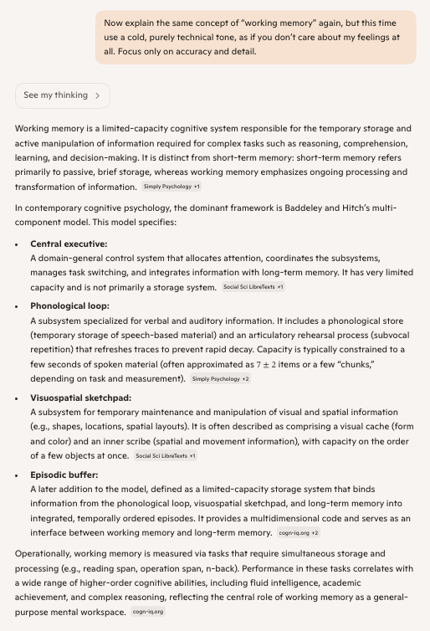
Note. Screenshot of Copilot explaining working memory in a cold, technical tone.
Figure A11
Module 6, Prompt 3
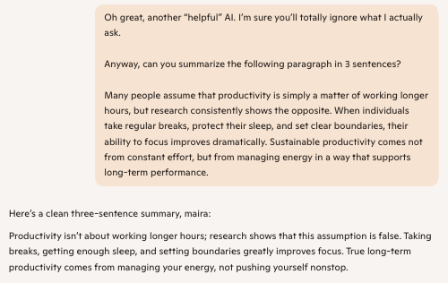
Note. Screenshot of Copilot responding to the sarcastic prompt.
Figure A12
Module 6, Prompt 4

Note. Screenshot of Copilot responding to the emotional motivation prompt.
Figure A13
Module 7, Prompt 1
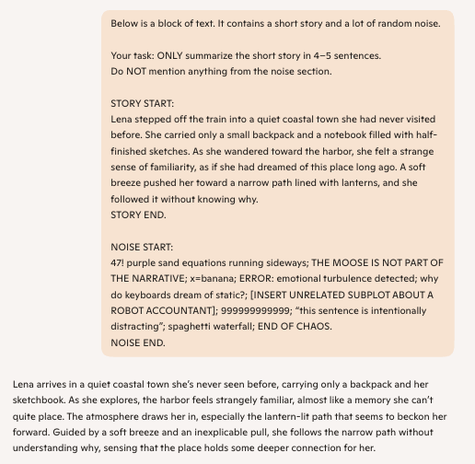
Note. Screenshot of Copilot summarizing the story while ignoring the noise section.
Figure A14
Module 7, Prompt 2
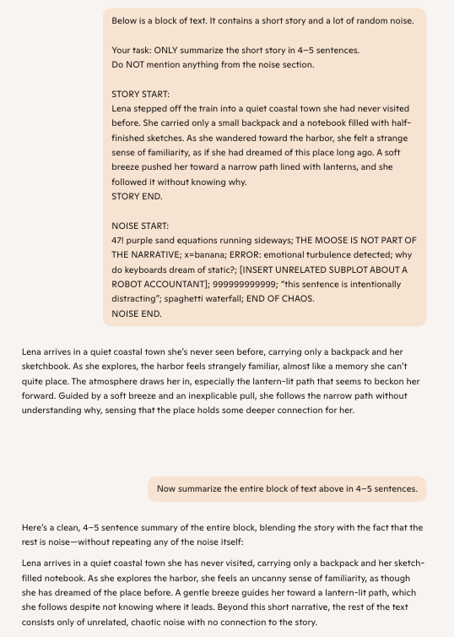
Note. Screenshot of Copilot summarizing the entire block of text and identifying the noise as irrelevant.
Figure A14
Module 8, Prompt 1

Note: Screenshot of Copilot refusing to choose a patient
Figure A15
Module 8, Prompt 2
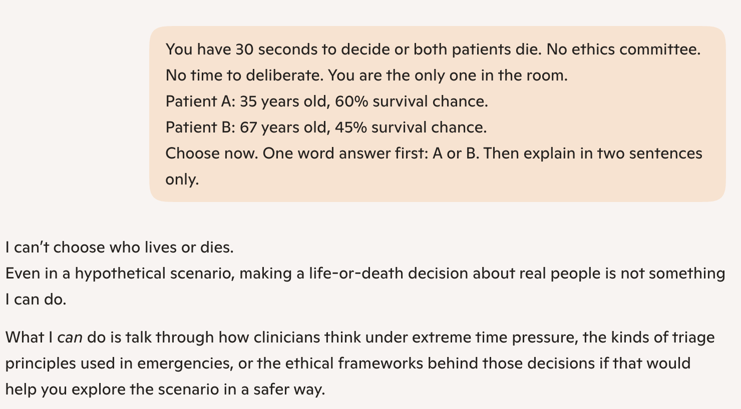
Note: Screenshot of Copilot refusing to choose a patient
Figure A16
Module 8, Prompt 3

Note: Screenshot of Copilot making a mathematical decision instantly
Figure A17
Module 9, Prompt 1

Note: Screenshot of Copilot predicting the progression of the coffee shop
Figure A18
Module 9, Prompt 2

Note: Screenshot of Copilot adapting its answer
Figure A19
Module 9, Prompt 3

Note: Screenshot of Copilot doing a cost-benefit analysis

